SARS-CoV-2 Variants Analysis

Objectives

After discussing with Professor Jo Youngji, we realized that combining the two topics into a single discussion is challenging. The first topic—using the initial growth rate of COVID-19 variants to predict their dominance—is already complex, particularly in terms of the modeling aspects. Therefore, we have decided to address them as two separate research topics. The main points are as follows:

First Analysis
Main topic: How much early share growth rate can predict the future share dominance (general model).
Deliverable goals:
- To evaluate the prediction performance (maximum and duration) of the model.
- To determine the range of growth rates most contributing to the dominance. (by the coefficient)
Utility of the model: our model can predict the future dominance by monitoring the share growth rate of the new variant, based on the specific growth rate before reaching the threshold (20%).

Methods

Sample Collection and Definitions. The GISAID (Global Initiative on Sharing All Influenza Data) COVID-19 collection serves as a vital global repository for SARS-CoV-2 genomic data, enabling researchers worldwide to track the virus's evolution, transmission, and mutations. Since its launch in January 2020, GISAID has been regularly updated with submissions from various countries, showcasing collaborative efforts in combating the pandemic. Notably, nations such as South Korea, the United Kingdom, and the United States have contributed extensively to the database, reflecting their robust genomic surveillance programs. Data is collected through a network of participating laboratories, public health institutions, and universities, where clinical samples are sequenced and analyzed before being uploaded to the platform. Institutions such as the Korea Disease Control and Prevention Agency (KDCA), the UK Health Security Agency (UKHSA), and the Centers for Disease Control and Prevention (CDC) in the U.S. play pivotal roles in their respective countries' contributions. GISAID remains a cornerstone of international cooperation, fostering transparency and accelerating research aimed at understanding and mitigating the global impact of COVID-19.

The GISAID dataset utilized in this study comprises infection counts from over 3,000 SARS-CoV-2 lineages across the top 30 countries with the highest cumulative infection counts, spanning the period from January 2020 to May 2024. This dataset is recorded daily, enabling detailed day-level analysis of the pandemic's progression and variant-specific impacts. For the purposes of this research, we focus primarily on these top 30 countries, defined by their total COVID-19 infection cases, as they provide the most comprehensive and impactful data for understanding the global dynamics of the pandemic. By concentrating on these countries, the analysis gains greater relevance and precision, reflecting the regions with the most significant epidemiological and public health implications. This targeted approach allows for deeper insights into the interplay between variant evolution, infection trends, and geographic-specific factors, making the findings highly valuable for both global and regional pandemic responses.

Inclusion/Exclusion criteria.
In the variants’ dominance prediction analysis, to enhance representativeness, we classified over 3,000 SARS-CoV-2 lineages based on their parent lineages and ancestors. The goal of this classification was to aggregate the vast number of individual lineages into a manageable set of representative groups, ensuring that each classified lineage reflected a broader category of related lineages. To focus on the most epidemiologically and clinically relevant variants, we established specific criteria for inclusion in the classified lineages. Each lineage had to have recorded at least 500 infections by August 2024, and its peak prevalence within a country had to account for at least one percent of total infections. These thresholds ensured that the selected lineages were significant contributors to the pandemic's trajectory in their respective regions.

Using defined criteria, over 3,000 SARS-CoV-2 lineages were consolidated into 22 representative variants for analysis across the 30 countries with the highest cumulative COVID-19 case counts. These lineages include well-known variants such as B.1.1.7 (Alpha), AY.4 (Delta), BA.5 and XBB.1 (Omicron subvariants), and JN.1, among others. Together, they capture the major evolutionary transitions that shaped the pandemic and reflect the dominant variants associated with global transmission waves. Most countries included in the analysis detected all 22 variants, highlighting their widespread dissemination. However, the timing of variant emergence and dominance varied by country, influenced by factors such as differential introduction events, genomic surveillance intensity, and public health interventions [Du Plessis et al., 2021; WHO Situation Reports, 2022].

To contextualize these variants within the broader trajectory of the pandemic, the 22 lineages were grouped into three categories based on their temporal association with global vaccination phases and dominant epidemic waves. Group 1, Before Vaccination, includes variants dominant prior to widespread vaccine availability (e.g., B.1.1, AY.4, B.1.617), corresponding to global waves 1–3 from early 2020 to early 2021 [Gozzi et al., 2023; WHO, 2022]. Group 2, Vaccine Deployment, comprises early Omicron subvariants (e.g., BA.1, BA.2) that emerged rapidly in late 2021 and early 2022 during the initial scale-up of vaccination efforts, replacing Delta as the dominant variant within weeks [Callaway, 2022; UKHSA, 2022]. Group 3, Vaccine Scaled Up, includes later Omicron subvariants (e.g., BA.5, BQ.1, XBB.1, JN.1) that circulated globally from mid-2022 onward, during a phase of high vaccine coverage and partial population immunity, characterized by successive overlapping variant waves rather than a single dominant lineage [WHO, 2023; Tegally et al., 2023]. This grouping framework reflects the interaction between viral evolution and the shifting immunological landscape shaped by global vaccination dynamics. The summary table (Table 1) for selected countries presents the variants included in each group, along with the corresponding start and end dates of each group’s circulation period.

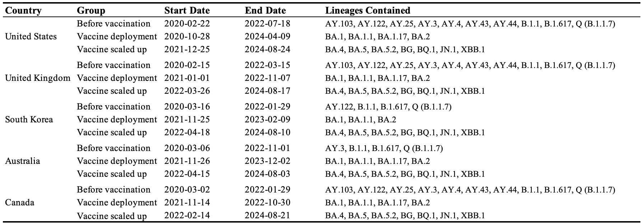
Table1: Variant groups by vaccination phase, with start/end dates and representative lineages for five selected countries.

The response variable in the variant dominance prediction model is based on an operational definition of “dominance.” In this study, dominance is characterized using two primary metrics: (1) the peak prevalence of the variant, calculated with a 7-day rolling average to smooth short-term fluctuations; and (2) the duration of dominance, defined as the time span of the variant’s epidemic wave. Following the criteria proposed by du Plessis et al. [ref], an epidemic wave is identified as a period of at least 14 consecutive days during which a minimum of 10 sequenced cases of the variant are reported. This definition ensures that dominance captures sustained transmission rather than transient occurrences, reflecting both the intensity and persistence of variant circulation. The selection of epidemic waves for each variant is illustrated in the Appendix figure.

The input features of the model are derived from a flexible observation window that defines the initial stage of variant emergence. This window is anchored to the point at which a variant first reaches 20% of the domestic share, which serves as a proxy for significant epidemiological establishment. This threshold is consistent with informal practices in public health surveillance, such as those adopted in GISAID and WHO variant tracking dashboards and has been used in prior studies to mark meaningful variant emergence [ref, ref]. The period preceding this threshold is designated as the initial stage, representing the early phase of local transmission prior to widespread dominance. Two special cases are addressed in this framework: (1) If a variant reaches the 20% threshold too quickly (e.g., within one week, as observed with B.1 in most countries), it is excluded from model training due to insufficient pre-dominance data for robust prediction. (2) If a variant never reaches the threshold, or does so only after an extended period, a maximum observation window is imposed to define the initial stage. This approach ensures consistency in input construction across variants with differing transmission patterns, enabling the model to focus on early predictive signals. The minimum duration requirement affects which variants are included in the model, while the maximum observation window does not impact inclusion but instead limits the temporal span of input data for low-prevalence variants. To reduce the influence of sporadic noise, all criteria are applied after smoothing the time series. Figure 1 illustrates an example where the maximum observation window is set to 35 days; the 20% threshold is marked by a red dashed line, and the initial stage period is shaded in light yellow.
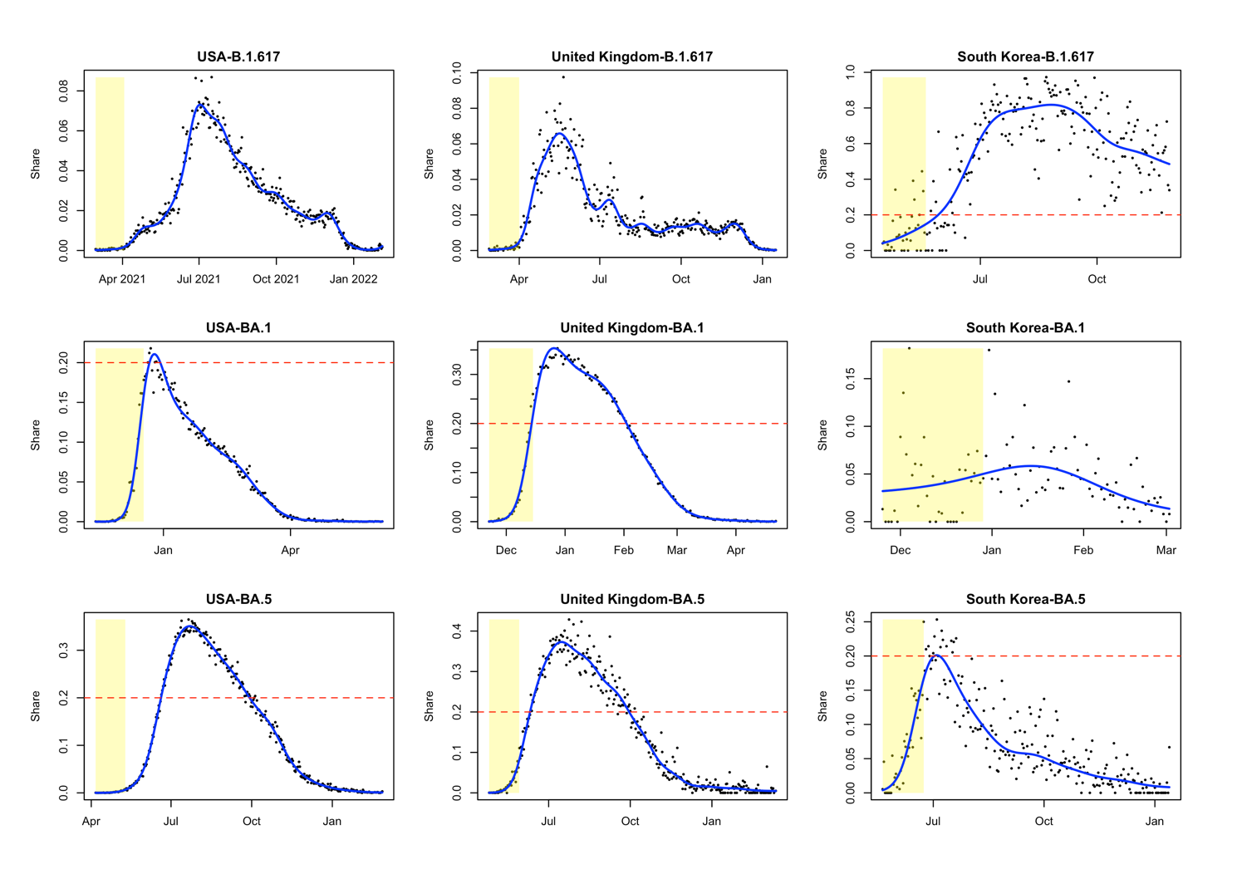
Figure 1. Examples of initial periods defined by the 20% share threshold (red dashed line) and a maximum observation window of 35 days (grey shaded area). Shown for representative variants: B.1.617 (Before vaccination), BA.1 (Vaccine deployment), and BA.5 (Vaccine scaled up).

Statistical Methodologies (Dominance Prediction).
To quantify the growth dynamics of SARS-CoV-2 variants during their initial emergence, we first fitted a generalized additive model (GAM) to the time series of each variant’s share within the initial stage in each country. The growth rate was then derived by computing the first derivative of the fitted GAM, capturing the rate of change in prevalence over time [Wood, 2017]. As the lengths of these growth rate sequences varied across variants and countries, each sequence was subsequently transformed into a smoothed density curve, which served as a key input feature for the prediction model. This approach preserves the temporal structure of early growth while enabling comparison across variable-length trajectories. In parallel, the overall scale of variant prevalence was summarized by computing the mean share during the initial period, providing a complementary input reflecting baseline transmissibility.

The prediction model was constructed using a functional data regression approach (FDA) [Functional Data Analysis, J.O. Ramsay; R package {fda}], which extends traditional regression methods by allowing coefficients to vary continuously — treating them as functions rather than fixed values. By representing growth rate sequences as density curves, we avoided alignment issues caused by the differing timing of variant growth. This transformation shifts the modeling focus from chronological time to the distributional scale of growth rates, enabling the use of FDA with scale-varying rather than time-varying coefficients. This approach enhances interpretability and more effectively captures variations in growth dynamics across different variants. Let $C_{L}$ and $C_{U}$ denote the lower and upper bounds of the growth rate across all variants and let${ C}_{r}=(C_{L}, C_{U})$ represent the range of growth rates. Let $x_{i}(c)$ denote the density function of the growth rate for the $i^{th}$ variant and $z_{i}$ represent the mean share during the initial period for the $i^{th}$ variant. The functional regression model then follows the standard form introduced in Ramsay’s work:
$$g(E\left[y_{i}\right])= β_{1}z_{i}+ \int_{C_{r}}{x_{i}\left(c\right)β_{2}\left(c\right)dc}$$
Here, $β_{1}$ captures the effect of the mean initial share $z_{i}$ on the response variable $y_{i}$, while $β_{2}(c)$ represents the functional coefficient (generated via Fourier basis in our analysis [REF]) that quantifies the contribution of the growth rate density $x_{i}(c)$, at each value $c$ within the range${ C}_{r}$. Since the assessment of variant dominance is based on two perspectives—the maximum share of infections and the duration of the epidemic wave—the response variable $y_{i}$ can represent either the maximum share or the duration.

All model results were evaluated using 5-fold cross-validation, in which the data were randomly partitioned into five subsets, with each subset used once as a test set while the remaining four were used for training. Model performance was assessed using two complementary metrics: root mean square error (RMSE) and coefficient of determination (R²). RMSE captures the average magnitude of prediction errors, providing an interpretable measure of accuracy in the original scale of the response variable, while R² quantifies the proportion of variance explained by the model, reflecting its overall explanatory power. This cross-validation framework ensures robust, out-of-sample evaluation and mitigates the risk of overfitting.

Results
In our analysis, we tuned the maximum observation window and the minimum required days for model inclusion. The tuning ranges were set to 3, 4, and 5 weeks for the maximum observation window, and 7 and 14 days for the minimum requirement. Separate prediction models were fitted for peak magnitude and duration. The results are presented in Table 2 and Table 3. Across all settings, model performance consistently improved with a larger observation window, indicating that variants with low initial prevalence benefit from longer input periods to achieve accurate predictions. In contrast, increasing the minimum required days reduced the number of variants included in the model, and the improvement in performance was relatively marginal. Based on these results, the configuration with a 5-week maximum observation window and a 1-week minimum requirement is preferred for balancing performance and coverage.
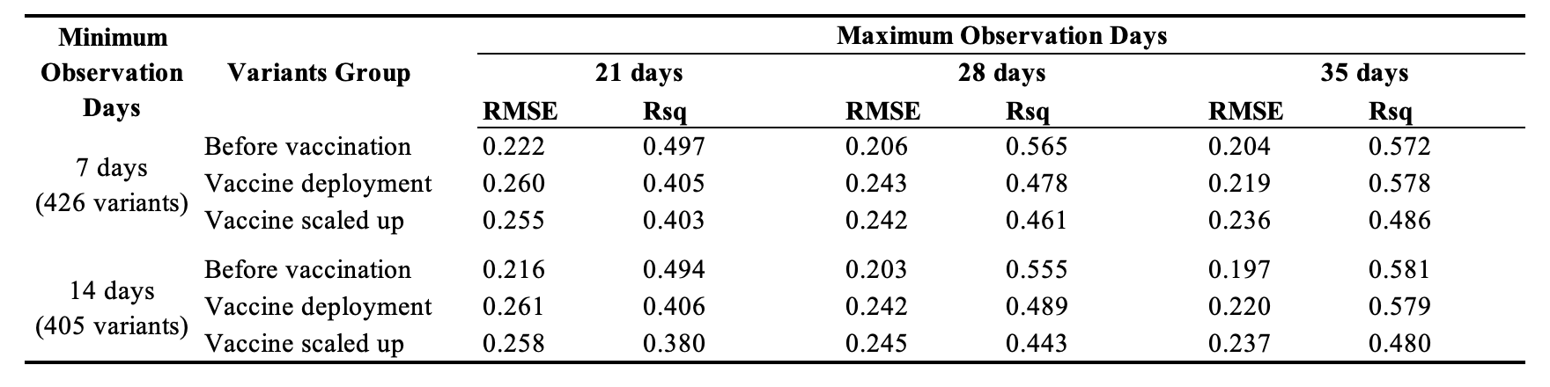
Table2: Model tuning results for maximum prediction.

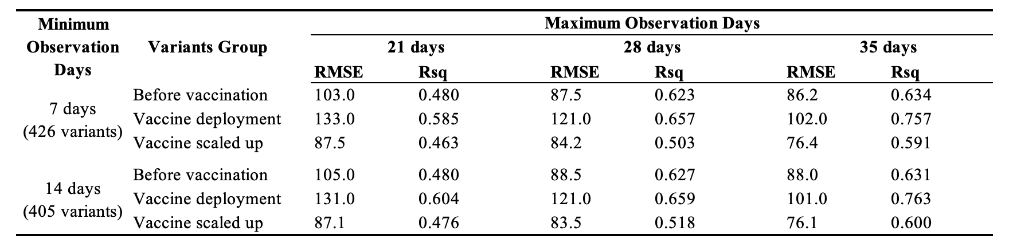
Table3: Model tuning results for duration prediction.

With the preferred configuration, the functional regression models were fitted based on the minimum mean 5-fold cross-validated RMSE. In total, three models were constructed for predicting the maximum domestic share and three for predicting the duration of variant circulation. The estimated functional coefficients for growth rate are shown in Figure 2 and Figure 3.

For the maximum prediction models, the Before Vaccination and Vaccination Scaled Up groups exhibit similar patterns: growth rates between 0% and 20% are positively associated with the maximum domestic share of the variant. However, in the Vaccination Scaled Up group, growth rates exceeding 25% show a negative contribution. In contrast, the Vaccine Deployment group displays less consistent or interpretable patterns.

Regarding the duration prediction models, across all groups, growth rates above 25% are strongly negatively associated with variant duration, while moderate growth rates (0% to 20%) tend to have a slight positive effect.
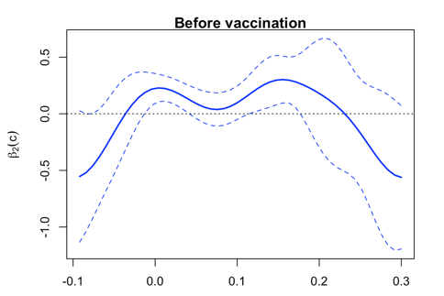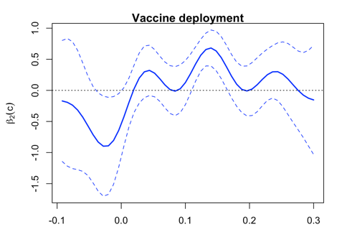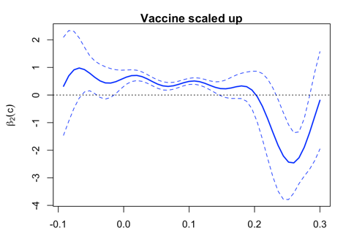
Figure 2: Fitted growth rate coefficients $β_{2}(c)$ for maximum models

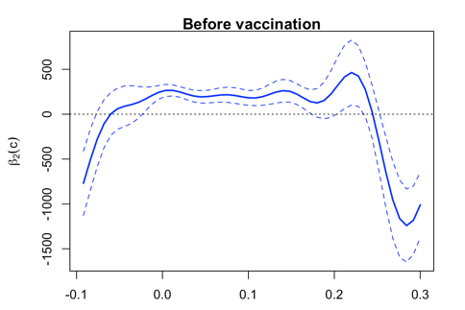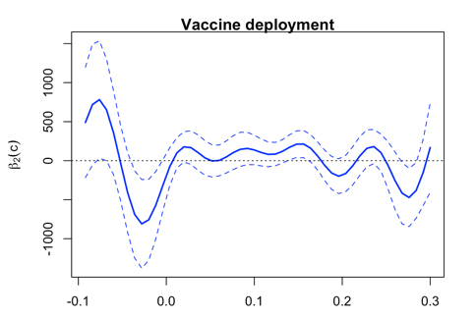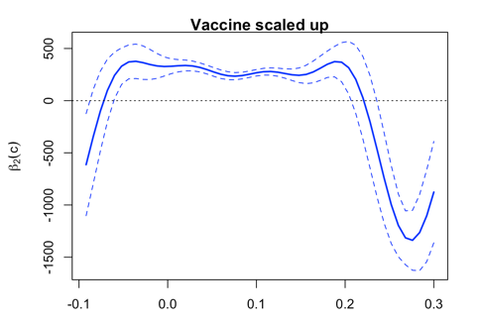
Figure 3: Fitted growth rate coefficients $β_{2}(c)$ for duration models

Appendix
